Subject Name: **Front-end Engineering**

Subject Code: **CS186**

Cluster: **iGamma** Group: **G19**

Department: **DCSE**



|  |  |  |
| --- | --- | --- |
| **Submitted By:**  Pankaj Kumar  2110991956  G19 |  | **Submitted To:**  Mrs. Pritpal |

**Index**

|  |  |  |
| --- | --- | --- |
| S. No | Program Title | Page No. |
| 1 | Introduction | 3 |
| 2 | Technologies Used | 4-5 |
| 3 | Key Objectives | 6 |
| 4 | Why HiTech-AI (Chat GPT Clone)? | 7 |

**HiTech-AI- Building an AI Chatbot with OpenAI's GPT-3 API**

**Project Overview:**

The ChatGPT Clone **(HiTech-AI)** project is an exciting endeavor that explores the capabilities of the GPT-3 model to build an AI chatbot that can engage in human-like conversations, provide information, and assist users across various domains. This AI chatbot will be designed to perform tasks such as answering questions, generating text, and maintaining engaging conversations with users.

**Introduction**

In the age of artificial intelligence, chatbots have become an integral part of our digital landscape, enhancing customer service, automating tasks, and providing interactive experiences. OpenAI's GPT-3, a state-of-the-art language model, has revolutionized the field of natural language understanding and generation. This project, known as "**(HiTech-AI)**," aims to leverage the power of OpenAI's GPT-3 API to create a highly responsive and intelligent AI chatbot that can adapt to a wide range of user needs and contexts. With its ability to comprehend and generate human-like text, GPT-3 has the potential to offer users a more natural and engaging conversational experience.

By harnessing the capabilities of this technology, the "**(HiTech-AI**" project seeks to deliver cutting-edge solutions in areas like customer support, content generation, and even companionship in the digital realm, marking a significant milestone in the evolution of AI-powered chatbots. As we continue to push the boundaries of what is possible with AI, we can expect chatbots like **(HiTech-AI)** to become even more sophisticated and indispensable in our increasingly AI-driven world

**Technologies Used**

Certainly, let's go through with the technology section for the project’s documentation. In this section, we can detail the technologies and concepts used in your project, specifically focusing on how React, **useState**, **API** integration, **setInput**, and **handleEnter** play a key role in building your ChatGPT clone.

**React:** Your project is built using the React library, a popular JavaScript library for building user interfaces. React's component-based architecture will be essential in creating a dynamic and interactive chatbot interface.

**useState Hook:** In React, the useState hook is used to manage state within functional components. You will use useState to manage the input text, conversation history, and other relevant states in your chatbot.

**OpenAI GPT-3 API:** The OpenAI GPT-3 API is integrated to provide the chatbot's natural language understanding and generation capabilities. This API enables your chatbot to understand user inputs and generate contextually relevant responses.

**Key Concepts and Functions:**

**State Management with useState:** You'll use the useState hook to manage the application's state. For example, you can maintain the state of the input text, conversation history, and other relevant information. This ensures that the user interface reflects the most up-to-date information.

**User Input Handling:** The setInput function is used to update the user's input in real-time as they type. This allows for a dynamic and responsive user experience as users interact with the chatbot.

**useEffect Hook:** The useEffect hook is a critical aspect of your project for managing side effects in functional components. You can use it to execute code in response to specific events, like sending and receiving messages from the OpenAI API.

**Asynchronous Function:** In React, handling asynchronous operations, such as API calls, is essential for maintaining a smooth user experience. You'll use the async keyword to indicate that a function is asynchronous, ensuring that your chatbot can communicate with the GPT-3 API without blocking the user interface.

**Handling User Submissions with handleEnter:** The handleEnter function is crucial for capturing user input and initiating a response from the chatbot. This function is typically triggered when the user presses the "Enter" key after typing a message.

**API Integration:** Your project's interaction with the GPT-3 API is a core component. This involves sending user input to the API, receiving responses, and displaying them in the chat interface. You'll also handle error scenarios and edge cases in API communication.

**User Interface Development:** While not explicitly mentioned, your project will involve creating and styling the chatbot's user interface using HTML and CSS to ensure a visually appealing and user-friendly design.

By combining React, useState, asynchronous functions, user input handling, and API integration, we have created a fully functional chatbot.

**Key Objectives**

**1. Implement the GPT-3 API:** The project will begin by integrating OpenAI's GPT-3 API into the chatbot system, allowing it to understand user inputs and generate contextually relevant responses.

**2. Customization and Training:** We'll explore methods for customizing the chatbot's behavior and training it to suit specific applications, whether it's for customer support, content generation, or any other domain.

**3.User Interaction:** The chatbot will be designed to handle various types of user interactions, including text-based conversations, voice inputs, and potentially even multi-modal interactions.

**4. Enhanced User Experience:** The project will focus on making the chatbot's responses coherent, informative, and engaging, so that users feel like they are talking to a knowledgeable and personable virtual assistant.

**5. Deployment and Scaling:** The chatbot will be deployed in a suitable environment, and we will explore methods for scaling the system to handle a larger user base efficiently.

**Why HiTech-AI (Chat GPT Clone)?**

Creating a ChatGPT clone with OpenAI's GPT-3 API offers a wealth of possibilities, from improving customer service to automating repetitive tasks. It also serves as a fantastic opportunity to explore the latest advancements in natural language processing and machine learning. As we build this clone, we will gain valuable insights into the capabilities and limitations of state-of-the-art AI models and their potential impact on industries.

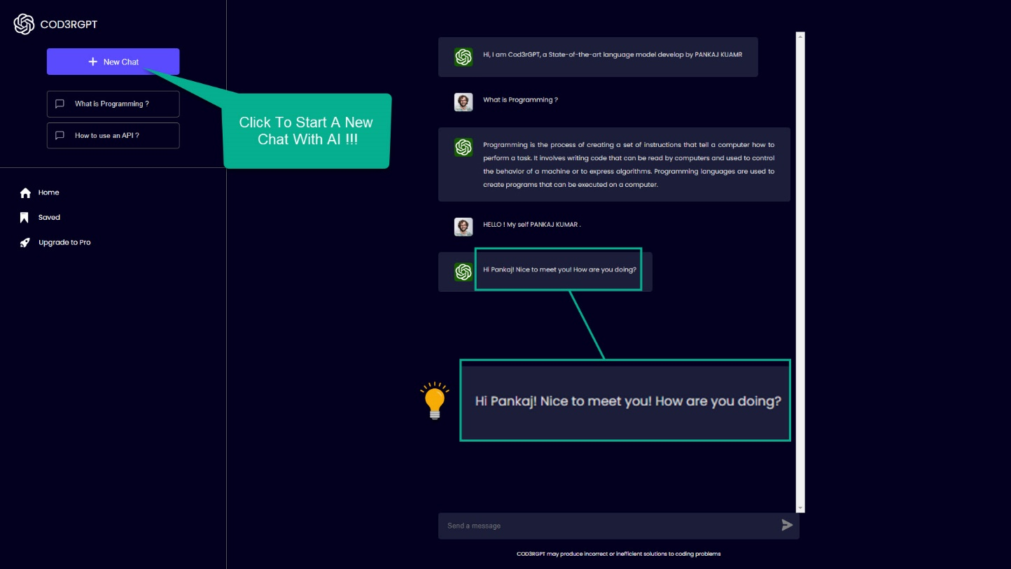

This project invites us to embark on a journey to harness the power of AI and create a chatbot that can make human-computer interactions smarter, more engaging, and seamless. Whether you are a developer, AI enthusiast, or business owner, the ChatGPT Clone project promises to open up exciting avenues for exploration and innovation.